TAJUK MANUSKRIP (TNR, 16, BOLD, CENTER, SINGLE SPACING, UPPERCASE)

3rd SKPPT

2026

MANUSCRIPT TITLE (TNR, 14, BOLD, ITALIC, CENTER, SINGLE SPACING, UPPERCASE)

Author A ^{1* (superscript)}
Author B ² (^{superscript})
Author C 3 (^{superscript})
(TNR, 12, Bold, Centre, Single Spacing, Capitalize Each Word)

(^{superscript}) ¹ Author A affiliation: Department/faculty/school, University/Institution, City and postal code, State, Country (E-mail: Author A@uuu.edu.my)
(^{superscript}) ² Author B affiliation: Department/faculty/school, University/Institution, City and postal code, State, Country (E-mail: Author B@uuu.edu.my)
(^{superscript}) ³ Author C affiliation: Department/faculty/school, University/Institution, City and postal code, State, Country (E-mail: Author C@uuu.edu.my)
*Corresponding author: Author A email address
___________________________________________________________________________
Abstrak: Text font is Times New Roman, 12 pt size, italic, and justify the alignment.

Kata Kunci: Min. 3 - Max. 7 Kata Kunci (Text font is Times New Roman, 12 pt size, italic, and justify the alignment)

Abstract: Text font is Times New Roman, 12 pt size, italic, and justify the alignment.

Keywords: Min. 3 - Max. 7 keywords (Text font is Times New Roman, 12 pt size, italic, and justify the alignment)

___________________________________________________________________________

Introduction – Heading 1 (TNR, 12, Bold, Align Left, Capitalize Each Word)
Tourism is one of the fastest growing development sectors in addition to other development strategic agendas such as energy, food, infrastructure ………….
(TNR, 12, single spacing, justify)

Literature Review – Heading 1 (TNR, 12, Bold, Align Left, Capitalize Each Word)
There are five point will be discussed in LR……
(TNR, 12, single spacing, justify)

Definition of Rural Tourism – Heading 2 (TNR, 12, Bold, Italic, Tab Inside, Capitalize Each Word)
Sustainable tourism as defined by The World Tourism Organization (UNWTO) is tourism that takes full account of current and future economic, social and environmental impacts…
(TNR, 12, single spacing, justify)

Rural Tourism – Heading 3 (TNR, 12, Bold, Italic, Tab Inside, Capitalize Each Word)
The goal of sustainable tourism is to reduce poverty, respect socio-cultural authenticity……
(TNR, 12, single spacing, justify)

Table 1: Example (TNR, 12, Single Spacing, Bold, Centre, Capitalize Each Word)
Example | Example | Example
Example | Example | Example
Example | Example | Example
Source: (TNR,10, Single Spacing, Align Left, Capitalize Each Word)

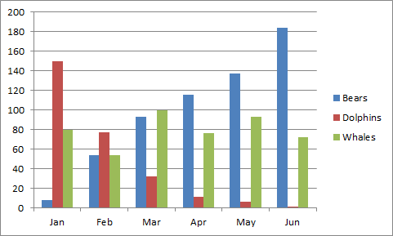
Figure 1: Example (TNR, 12, Single Spacing, Bold, Centre, Capitalize Each Word)
Source: (TNR,10, Single Spacing, Align Left, Capitalize Each Word)

References (APA Sixth Edition, Single Spacing)
Rohani M.M., & Yusoff, A. S. (2015). Tahap Kesediaan Pelajar Dalam Penggunaan Teknologi, Pedagogi, Dan Kandungan (TPACK) Dalam Pembelajaran Kurikulum di IPT. Proceeding of the 3rd International Conference on Artificial Intelligence and Computer Science, Pulau Pinang.

